**Innovation/Approach**

1. Ciarra Alemeria et al., Heterogeneity of mesenchymal stem cell-derived extracellular vesicles is highly impacted by the tissue/cell source and culture conditions [1].

Cell & Bioscience 2022 - Doi: 10.1186/s13578-022-00786-7

1. Describe the process parameters that crucially affect the MSC therapeutic properties and biological functions: cell source, medium composition.
2. The authors discuss the bioreactor culture which produce MSC-derived EV’s with less inflammatory factors and suppressed T cell and macrophage infiltration. We want to control the effects of the engineered MSC and notbeing pro-tumorigenic.
3. Additionally, bioreactors allow to scale up production, enable continuous culture and monitoring of critical process parameters, such as O2 and pH.
4. Description of common isolation protocols and more modern separation techniques for MSC-Evs.
5. The paper describes EV storage approaches.

Key considerations for MSC-derived EV production

EV Specific surface markers

1. Dupuis et al., Methods to produce induced pluripotent stem cell-derived mesenchymal stem cells: Mesenchymal stem cells from induced pluripotent stem cells- 2021 Aug 26. doi: [10.4252/wjsc.v13.i8.1094](https://doi.org/10.4252%2Fwjsc.v13.i8.1094) [2]

The source of the iPSC-MSCs and the method used for exosome preparation can influence their immunogenicity. Autologous sources (derived from the same individual receiving the exosomes) would theoretically pose the least risk of immune reaction, but allogeneic sources (from a donor) are also considered due to MSCs' naturally low immunogenicity.

1. Describe the main current protocols used to differentiate human iPSCs into MSCs: MSC Switch, Embryoid Body Formation, Specific Differentiation, Pathway Inhibitor, and Platelet Lysat.
2. The MSC Switch method emerges as the predominant choice, with six method variants cited over 100 times (refer to Table 1). It appears to be the least complex of the protocols, at the expense of, perhaps, increased variability of the obtained iMSCs

Relative frequencies of commercial media in 32 studies

Coating used to produce induce pluripotent stem cell-derive mesenchymal stem cells.

1. Zhijie Weng et al. Therapeutic roles of mesenchymal stem cell-derive extracellular vesicles in cancer. Journal of Hematology & Oncology 2021 - Doi: 10.1186/s13045-021-01141-y [3]
2. This review explores the diverse roles of MSDC-derived EVs, focusing particularly on their applications as anti-tumor agents. The characterization of MSCs often involves the assessment of specific protein markers, including CD9, CD63, CD81, CD59, as well as cytosolic proteins such as ALIX, TSG101, and Hsp70/90, through techniques like Western Blot or ELISA.
3. The review discusses the impacts of MSC-derived EVs on cancer cells, we may want to investigate the possibility to transect different MSC-derive types for different cancer types or use only iPSC-MSCs.
4. The review examines different strategies for cargo engineering, comparing pre-loading and post-loading techniques.

* CSF-1R inhibitors can be conjugated to the exosome surface using linker molecules that covalently attach to functional groups on the exosome membrane or the Lamp2b protein.
* For targeting TAMs, peptides that specifically to CD68 or CD163 could be identified or engineered.
* For cancer cells, short peptides or scFv (single-chain variable fragments) that recognize EpCam, HER2, or CA125 could be fused to Lamp2b. The paper references a study in which BMSC-derived exosomes were tagged with the 5TR1 aptamer, which has a close affinity with MUC1 protein
* Adding a glycosylation motif, such as GNSTM, to the fusions can indeed improve the stability and solubility of protein fusions. Glycosylation can enhance resistance to proteases and improve the overall pharmacokinetic properties of the exosomes.

Critical stages involved in utilizing MSD-derived EVs for therapeutic purpose:

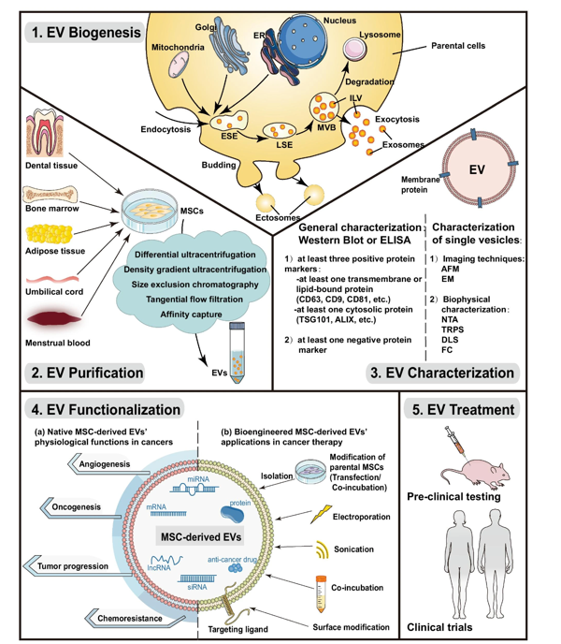

Current technologies for EV bioengineering

1. Jiaci Chen et al. Review on Strategies and Technologies for Exosome Isolation and Purification – 2022 Frontiers in Bioengineering and Biotechnology [4]
2. Review common exosomal separation techniques but also emerging technologies with better performance, simple and affordable such as microfluidic chip
3. Common exosome isolation technologies including ultracentrifugation (“gold standard”)

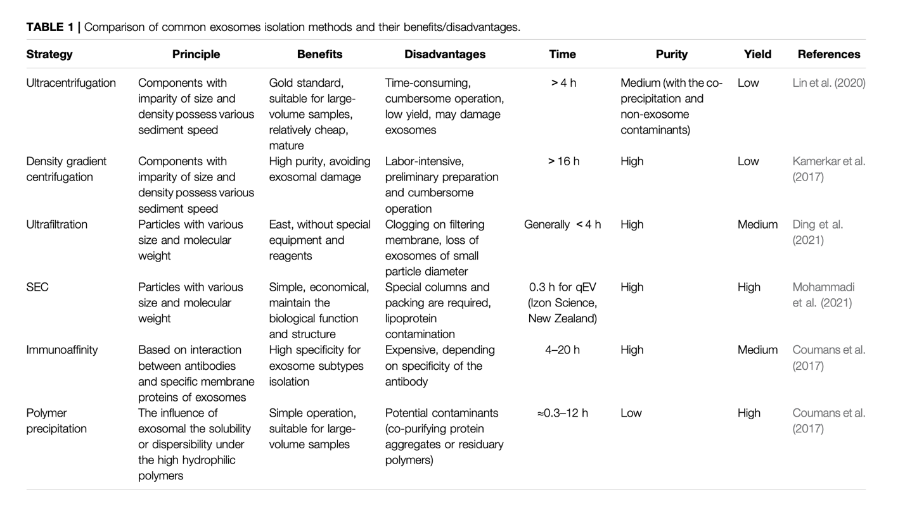

1. Description of microfluidic system which can isolate exosomes with high purity, minimizing contamination form other extracellular vesicles or protein aggregates. The process is more efficient and requires less time than ultracentrifugation techniques, it can be scaled up and the same system can be used for exosome modifications.

5) Luisa Pascucci et al, Paclitaxel is incorporated by mesenchymal stromal cells and released in exosomes that inhibit in vitro tumor growth: A new approach for drug delivery – Journal of Controlled Release – 2014 – Doi: 10.1016/j.jconrel.2014.07.042 [5]

1. This research describes the whole protocol for loading MSCs with the drug Paclitaxel (PTX) and isolated them using ultracentrifugation.
2. They used transmission (TEM) and scanning electron microscopy (SEM) to analyze the MSC’s membrane microvesicles (MVs) to understand their roles in the release mechanism of PTX.
3. They used the Fourier transformed infrared (FTIR) micro spectroscopy to detect PTX.
4. They used the murine SR4987 line as MSC model. When they loaded SR4987 with PTX (SR4987PTX), they found that they release of MVs but these MVs look like untreated SR4987. However, SR4987PTX-derived-MVs (SR4987PTX-MVs) were very effective at stopping the growth of human pancreatic cell line CFPAC-1.

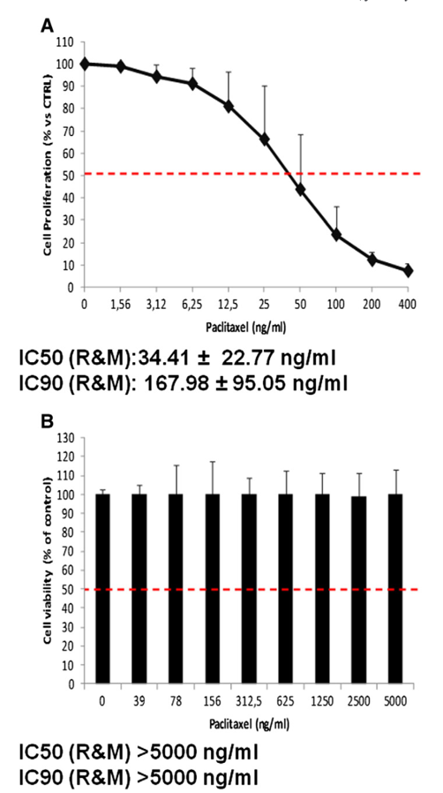

Sensitivity of SR4987 to PTX. Addition of a dose-dependent SR4987-CM was able to reduce the proliferation of CFPAC-1

Presence of PTX in SR4987PTX-CM is confirmed by HPLC analysis: peak on elution profile (A) is like profile (B) which is related to standard PTX at 1.000 ng/ml.

TEAM analysis if SR4987PTX shows an increased number of “vacuole-like” structures (MVs)

Anti-tumor activity of MVs from SR4987PTX.

1. Elnaz Bagheri et al., Targeted doxorubicin-loaded mesenchymal stem cells-derived exosomes as a versatile platform for fighting against colorectal cancer – Life Sciences 261 2020 – Doi: 10.1016/j.lfs.2020.118369 [6]

In this research, researchers encapsulated doxorubicin (DOX), a medication used to treat various cancers, including AIDS-associated Kaposi’s Sarcoma and metastatic cancers, through electroporation method with an encapsulation efficiency of up 35%.

For guided drug delivery against MUC-1-positive cancer cells, the MUC1 aptamer (5TR1), was covalently conjugated using ED/NHS chemistry with the amine groups on the surface of MSC-derived exosomes.

Characterization of exosomes isolated from murine MSCs

Flow cytometry analysis of CD63 and CD9 protein markers on the surface of the exosomes as positive markers.

SEM images of exosome with 500 and 200 nm scale bars

Cellular toxicity assessment of free DOC, DOX@exosome and DOX@exosome-apt

Tumor Cancer Cell MCF7 Cellular uptake with either DOX,DOX@exosome-apt, DOX@exosome and Control

The in-vivo efficiency of the different systems

* Fluorescent images proved that DOX@exosomes-apt exhibit significantly higher DOX accumulation at tumor site.
* In comparison with free DOX at 6 h post-injection, DOX@exosomes and DOX@exosomes-apt showed significantly low DOX concentration in heart tissues. The liver accumulation, 6 h post-injection was high for all groups while DOX@exosomes-apt injected group demonstrated faster liver clearance 24 h post-injection.

[1] C. Almeria, S. Kreß, V. Weber, D. Egger, and C. Kasper, “Heterogeneity of mesenchymal stem cell-derived extracellular vesicles is highly impacted by the tissue/cell source and culture conditions,” *Cell Biosci.*, vol. 12, no. 1, p. 51, 2022, doi: 10.1186/s13578-022-00786-7

[2] V. Dupuis and E. Oltra, “Methods to produce induced pluripotent stem cell-derived mesenchymal stem cells: Mesenchymal stem cells from induced pluripotent stem cells,” *World J. Stem Cells*, vol. 13, no. 8, pp. 1094–1111, 2021, doi: 10.4252/wjsc.v13.i8.1094

[3] Z. Weng *et al.*, “Therapeutic roles of mesenchymal stem cell-derived extracellular vesicles in cancer,” *J. Hematol. Oncol.*, vol. 14, no. 1, p. 136, 2021, doi: 10.1186/s13045-021-01141-y

[4] J. Chen *et al.*, “Review on Strategies and Technologies for Exosome Isolation and Purification,” *Front. Bioeng. Biotechnol.*, vol. 9, p. 811971, 2022, doi: 10.3389/fbioe.2021.811971

[5] L. Pascucci *et al.*, “Paclitaxel is incorporated by mesenchymal stromal cells and released in exosomes that inhibit in vitro tumor growth: A new approach for drug delivery,” *J. Control. Release*, vol. 192, pp. 262–270, 2014, doi: 10.1016/j.jconrel.2014.07.042

[6] E. Bagheri, K. Abnous, S. A. Farzad, S. M. Taghdisi, M. Ramezani, and M. Alibolandi, “Targeted doxorubicin-loaded mesenchymal stem cells-derived exosomes as a versatile platform for fighting against colorectal cancer,” *Life Sci.*, vol. 261, p. 118369, 2020, doi: 10.1016/j.lfs.2020.118369